Asia pacific Medical Students' Training - Nepal

REGISTRATION FORM
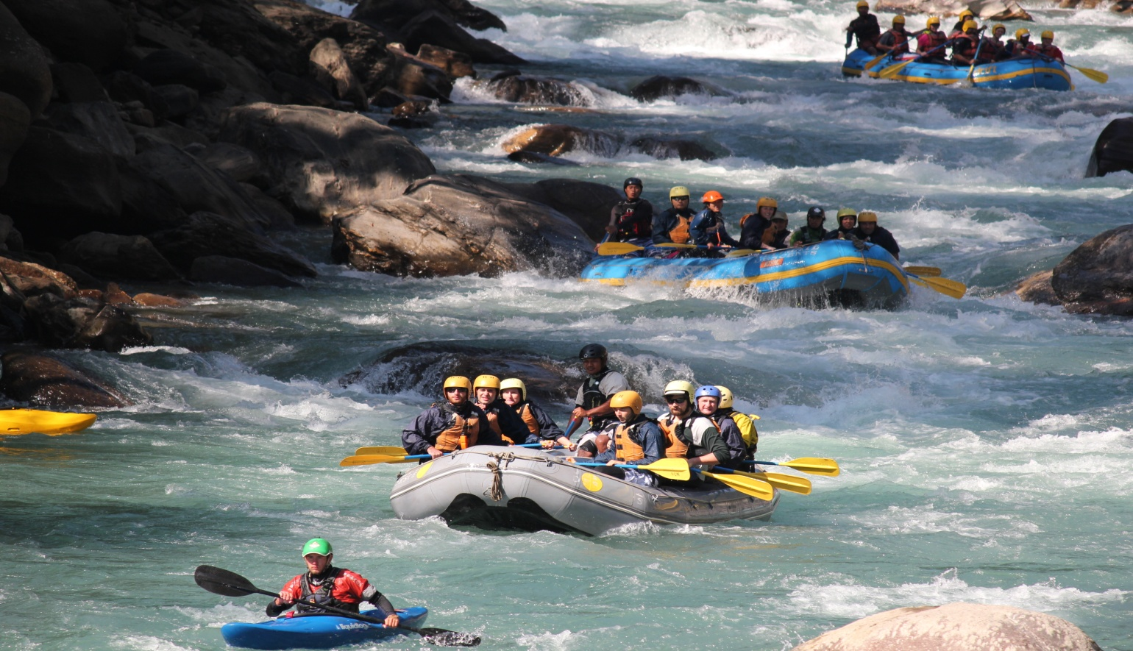
Note : Use Capital letters to fill up the form . e- signature will be valid .
Today’s date: |  |  |  |  |  |  |  |  |  |  |  |  |  |  |  |  |  |  | Time :

Applicants INFORMATION
Last name: |  |  |  |  |  |  |  |  |  | First: |  |  |  |  |  |  | Middle: | Mr.  Mrs. |  |  |  | Miss  Ms. |  |  | Marital status (circle one)
 |  |  |  |  |  |  |  |  |  |  |  |  |  |  |  |  |  |  |  |  |  |  |  |  | Single / Mar / Div / Sep / Wid
Is this your legal name? |  |  |  |  | If not, what is your legal name? |  |  |  |  |  |  |  |  |  | (English name): |  |  |  |  |  |  |  | Birth date: DD/MM/YYYY
Yes |  | No |  |  |  |  |  |  |  |  |  |  |  |  |  |  |  |  |  |  |  |  | / /
Age: |  | Sex: |  |  | M |  |  |  |  |  |  |  |  |  | F |  |  |  |  |  |  |  | Others
Street address: |  |  |  |  |  |  |  |  |  |  |  |  |  |  | ID no.: |  |  |  |  |  |  |  | phone no.:
P.O. box: |  |  |  |  | City: |  |  |  |  |  |  |  |  |  | State : |  |  |  |  |  |  |  |  |  |  | ZIP Code:
Occupation : |  |  |  |  | University : |  |  |  |  |  |  |  |  |  |  |  |  |  |  |  |  |  |  |  |  | Grade :
Passport Number : |  |  |  |  |  | Birth date: DD/MM/YYYY |  |  |  |  |  |  |  |  |  | Address (if different): |  |  |  |  |  |  |  |  |  | Phone no.:
 |  |  |  |  |  | / /
Date of Issue : |  |  |  |  |  | Expiry Date : |  |  |  |  |  |  |  |  |  | Issued from : |  |  |  |  |  |  |  |  |  | Birth place :
Have you travelled to Nepal before |  |  |  |  |  |  | Yes |  |  |  | No
Email Address :

Skype ID

Health Status
Blood Group / Rhesus |  |  | On Regular Medication  (Please specify) |  |  |  |  |  |  |  |  |  |  |  |  |  |  |  |  | Medication(please specify)
Allergy: |  |  |  | Yes |  |  |  |  | No |  |  | Specify (if any)
Others :

Food Specification
Meal restrictions |  |  |  |  |  |  |  | ( nil / Vegetarian / pork -free / chicken / Mutton ) please underline
Others( food allergy/ intolerance) / Nil

Food Recommendation ( if any )

IN CASE OF EMERGENCY
Name of local friend or relative : |  |  |  |  |  |  |  |  |  |  |  |  |  | Relationship :
Home phone no.: |  |  |  |  |  |  |  |  |  |  |  |  |  | Work phone no.:
The above information is true to the best of my knowledge. I authorize my insurance benefits be paid directly to the physician. I understand that I am financially responsible for any balance. I also authorize Asia pacific Medical Students' Training - Nepal or insurance company to release any information required to process my claims.
 | Patient/Guardian signature
 |  |  |  |  |  |  |  |  |  |  |  |  |  |  |  |  |  |  |  |  |  |  |  | Date

